RIX2024 - Batch 1 - Jenkins Practical Assessment
12576 Nisanth Saravanan

W3H Analysis

Project Title: Multi-language Translation Microservice
What? |  | How?
1. What are the necessary modules?  A: Modules Needed:  1) Login and Registration.  2)User Dashboard.  2. What are the necessary functionalities of Login and Registration Modules?  A: Login and Registration Module:  1) Register User.  2) Login as User.  3. What are the necessary functionalities of User Dashboard?  A: User Dashboard:  1) Input string to translate and perform translations.  2) Filter Previous Translations.  4. What are the tables needed?  A: Tables Required:  - Translations  - Users  5. What are the fields of user table?  A: Fields of Users table:  - Id (Primary Key) - int  - Name – string  - Contact – int  - Password – string  6. What are the fields of the Translations table?  A: Fields of Expenses Table:  - Id (Primary Key) - int  - TranslateString – string  - FromLang – string  - ToLang - string  7. What are the must have dependencies?  A: Dependencies:  - axios  - react-router-dom  8. What are the validations in the application?  A: Overall validations list:  - Frontend simple JS Validations.  - Server Side validations.  - Form Validations. |  | Login and Registration Module:  1) Register User:  Method 1: Use Simple Form Page.  Method 2: Use a Modular Form Page.  Method 3: Use Google OAuth and other 3rd party services.  2) Login as User:  Method 1: Use Simple Form.  Method 2: Use a Modular Form.  Method 3: Use 3rd party services.  User Dashboard:  1) Input string to translate and perform translations:  Method 1: Use Simple Forms and Buttons to perform CRUD.  Method 2: Have separate pages for each operation  Method 3: Use Modals.  2) Filter Previous Translations:  Method 1: Use a simple search bar.  Method 2: Have tables and sorting buttons.  Method 3: Have a separate page to pick out exact results.
Login and Registration Module:  1) Register User:  Method 1: Use Simple Form Page.  A: Since the overall scale of the application is small and data needed is rather minimal, it’s wise to stick with traditional forms.  2) Login as User:  Method 1: Use Simple Form.  A: Since the overall scale of the application is small and data needed is rather minimal, it’s wise to stick with traditional forms.  User Dashboard:  1) Input string to translate and perform translations:  Method 1: Use Simple Forms and Buttons to perform CRUD.  A: Since the overall scale of the application is small and data needed is rather minimal, it’s wise to stick with traditional forms.  2) Filter Previous Translations:  Method 1: Use a simple search bar.  A: Effective as it may, the simple input field can be directly mapped with the Expenses that are being displayed. |  | Login and Registration Module:  1) Register User:  Method 2: Use a Modular Form Page.  A: Increases the complexity of the app, and also the fact that the number of needed inputs in rather minimal.  Method 3: Use Google OAuth and other 3rd party services.  A: Valid method but due to the scale of the application, this method is seemingly overkill.  2) Login as User:  Method 2: Use a Modular Form.  A: Increases the complexity of the app, and also the fact that the number of needed inputs in rather minimal.  Method 3: Use 3rd party services.  A: Valid method but due to the scale of the application, this method is seemingly overkill.  User Dashboard:  1) Input string to translate and perform translations:  Method 2: Have separate pages for each operation.  A: Since the admin needs all information in one place and also that the number of operations they can do is limited, it is best to have a single page control centre type.  2) Filter Previous Translations:  Method 2: Have tables and sorting buttons.  A: This method is also viable but not selected due to the slight increase in the number of code needed for its execution.  Method 3: Have a separate page to pick out exact results.  A: Having the all the data displayed in one page and search functionality in another is not idle. Hence, this method is rejected.
Why? |  | Why Not?

Output Screenshots

Jenkins Initial Run

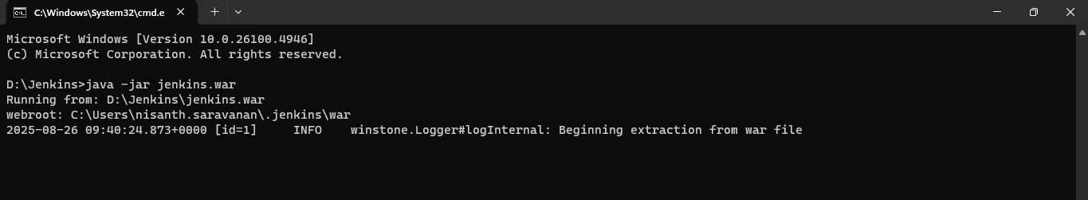

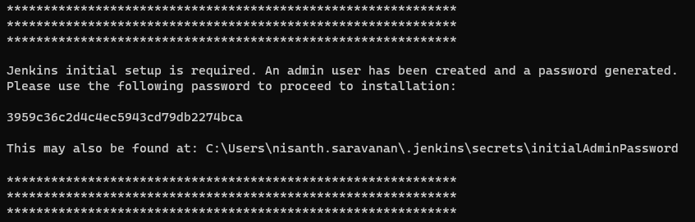

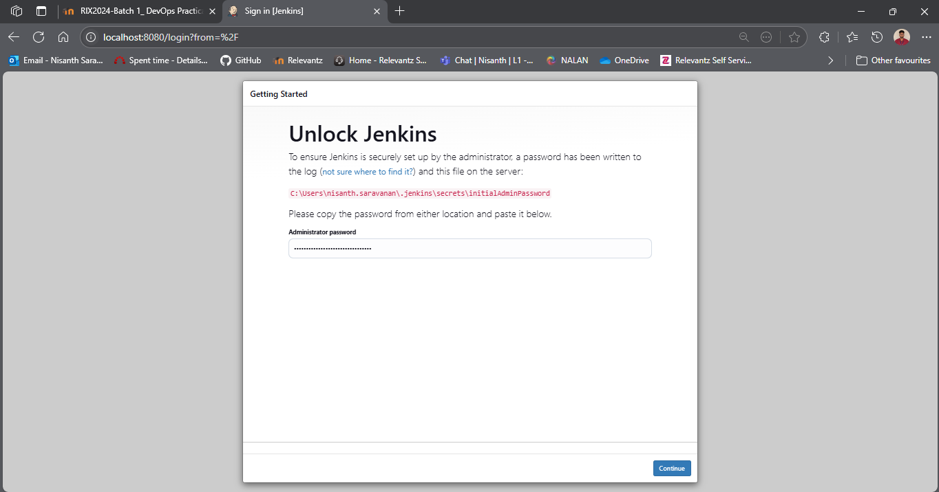

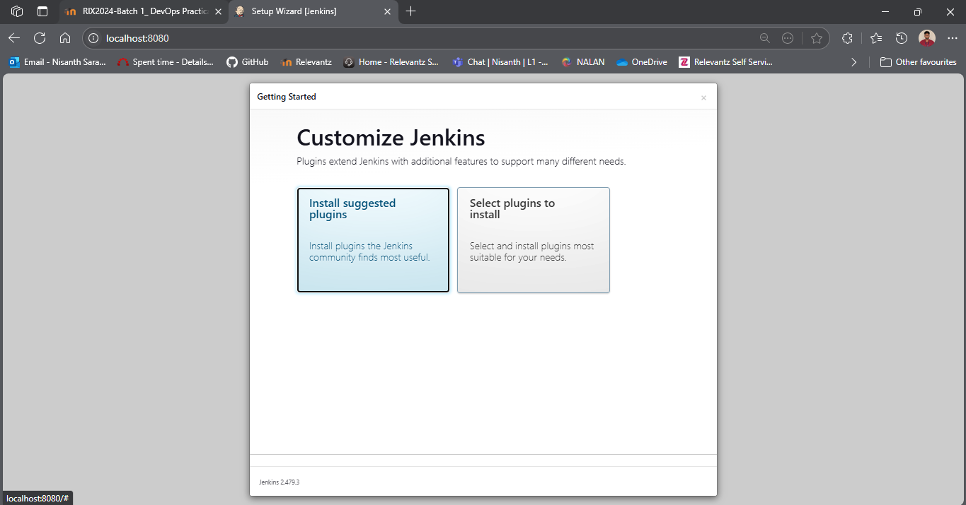

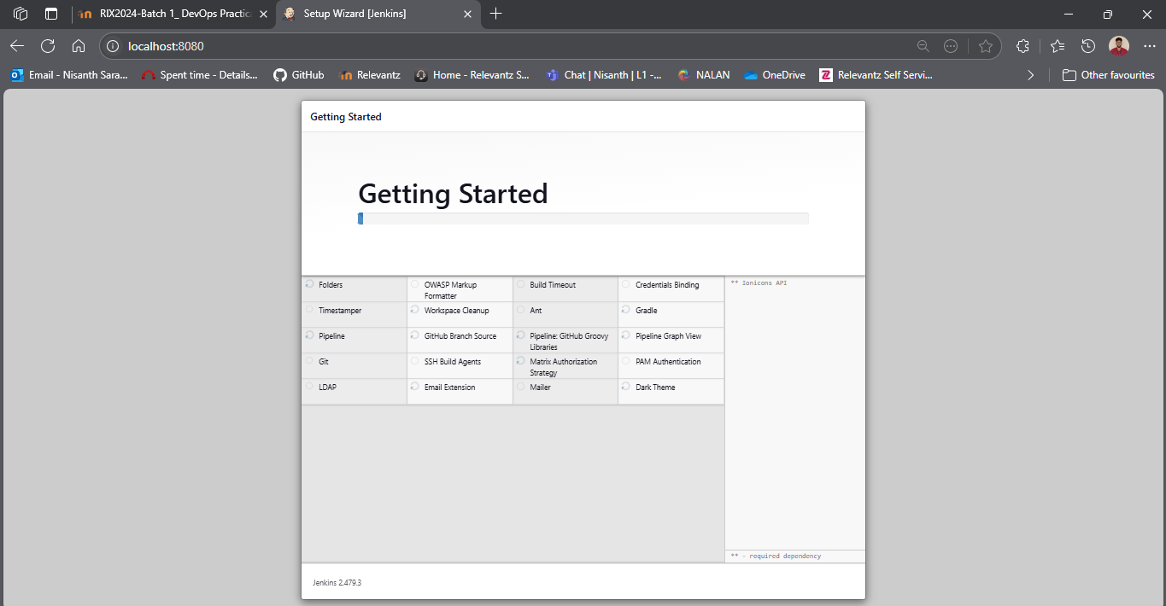

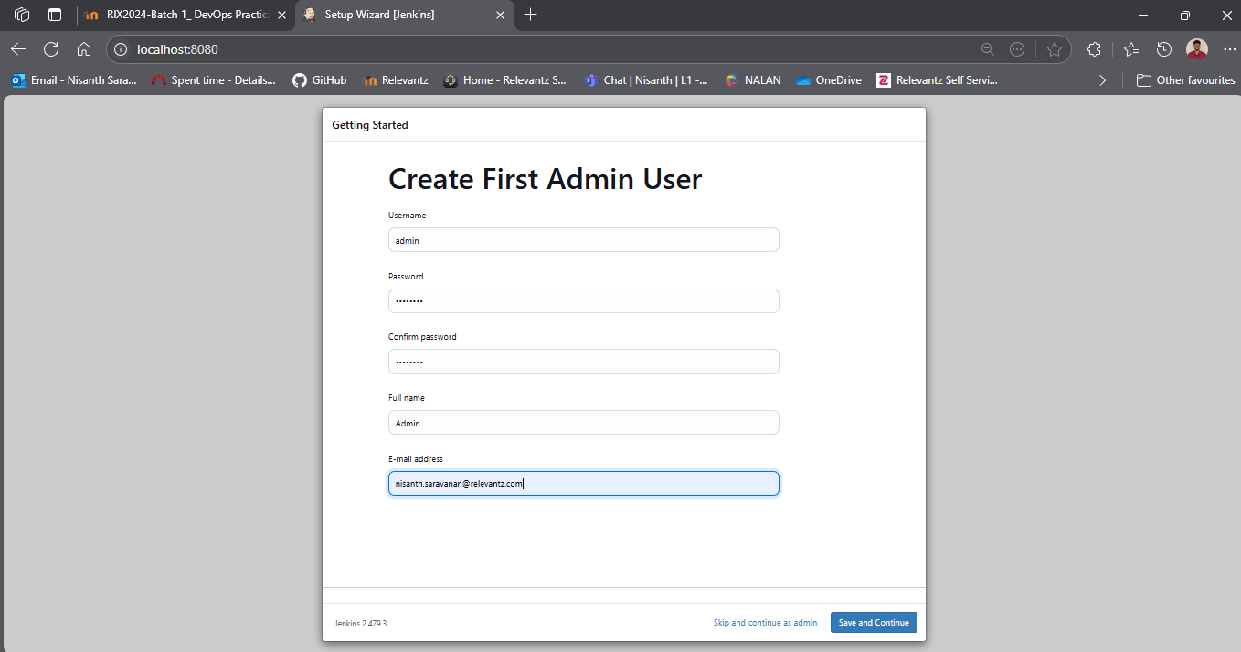

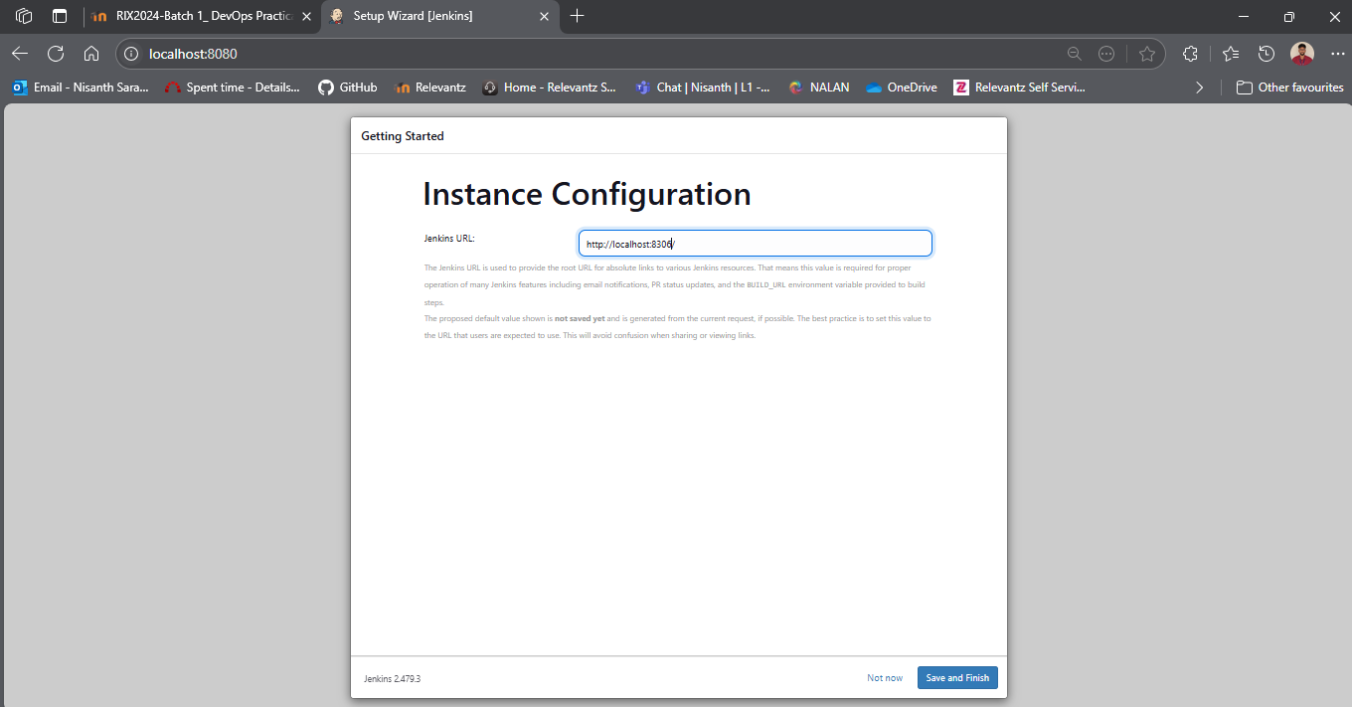

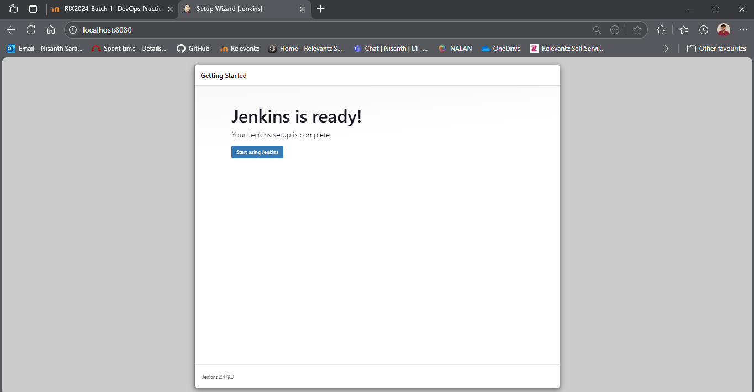
Configuring Jenkins

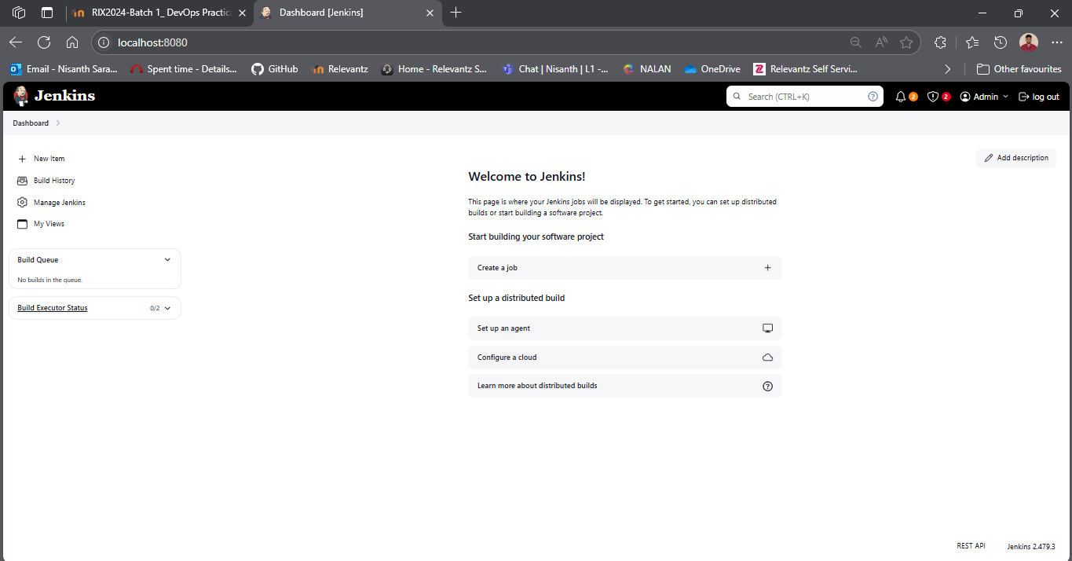

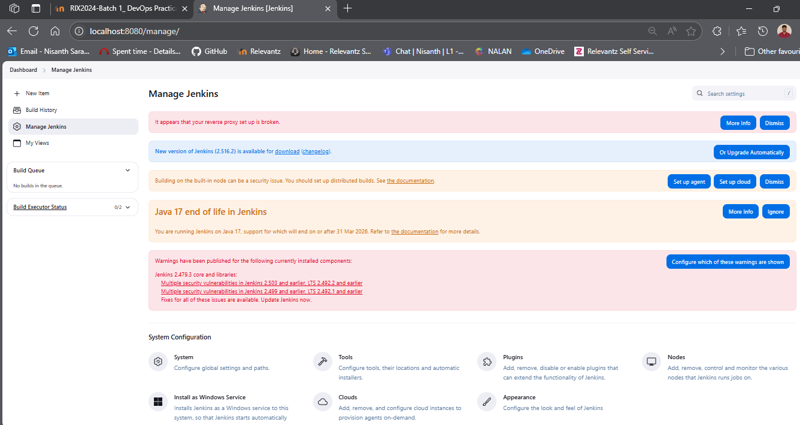
Plug-ins

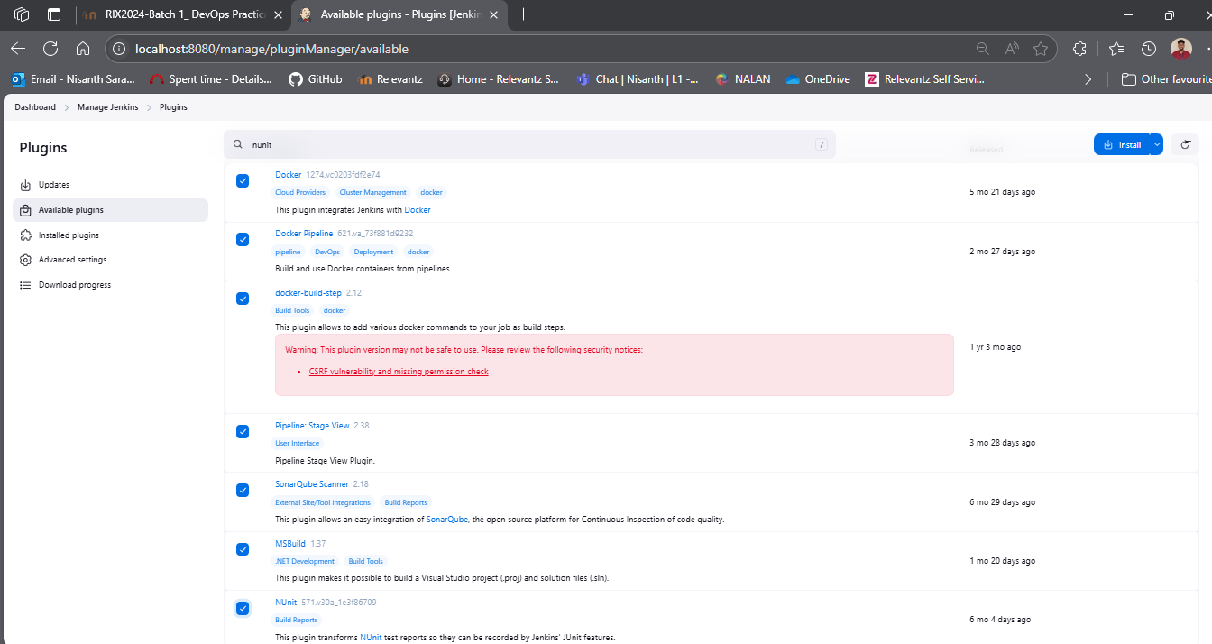

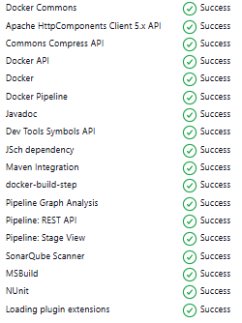
System:

SonarQube

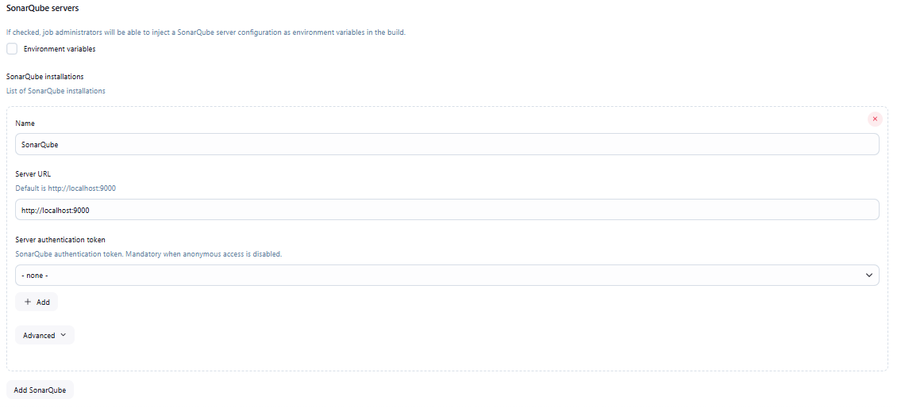

Docker

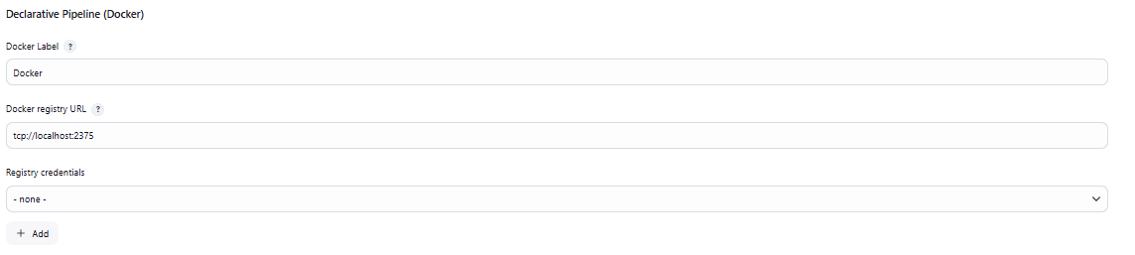
Tools

Java

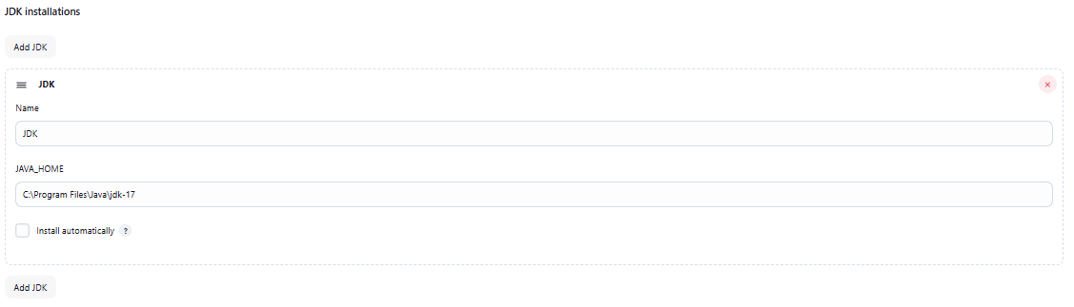

Git

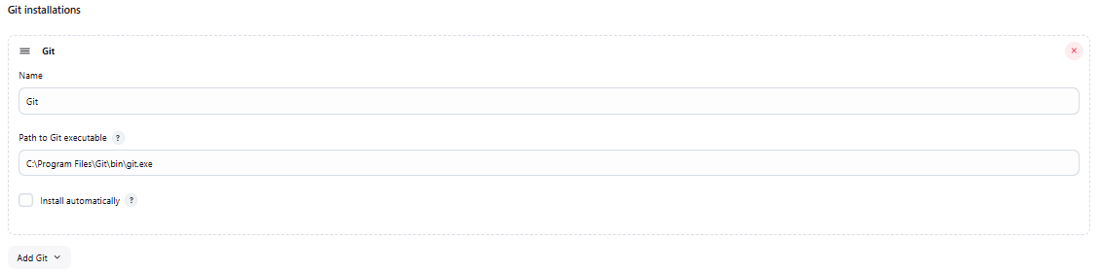

MSBuild

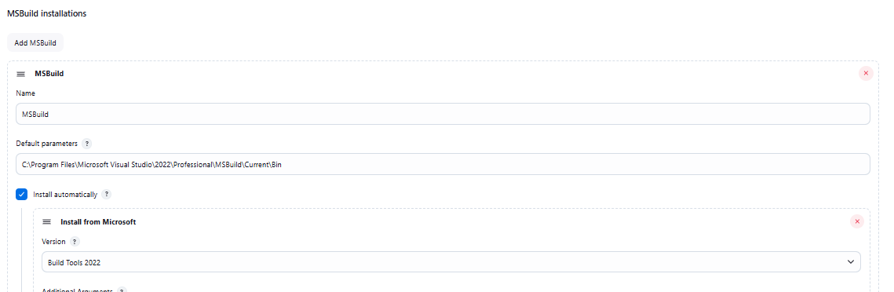
SonarQube

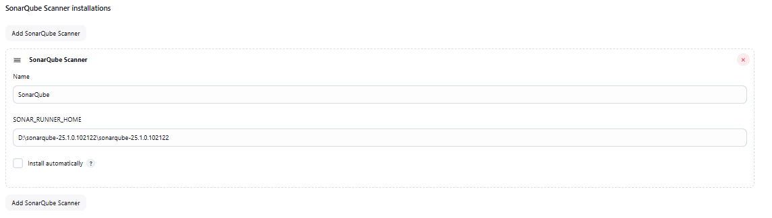

Docker

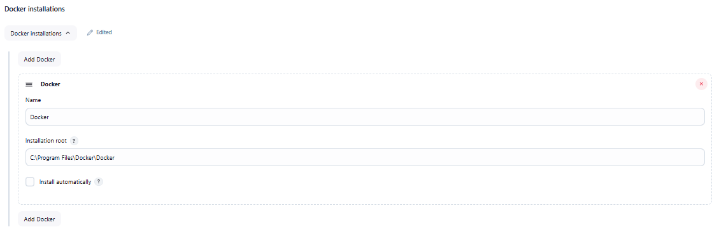
Getting Ready

Creating a new public repository

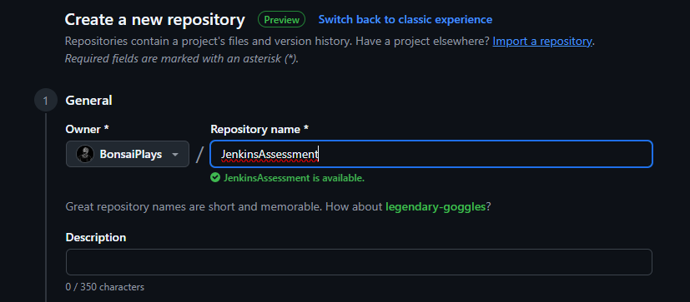

Pushing the existing code into the repository

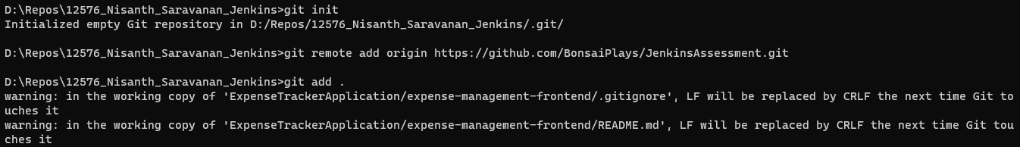

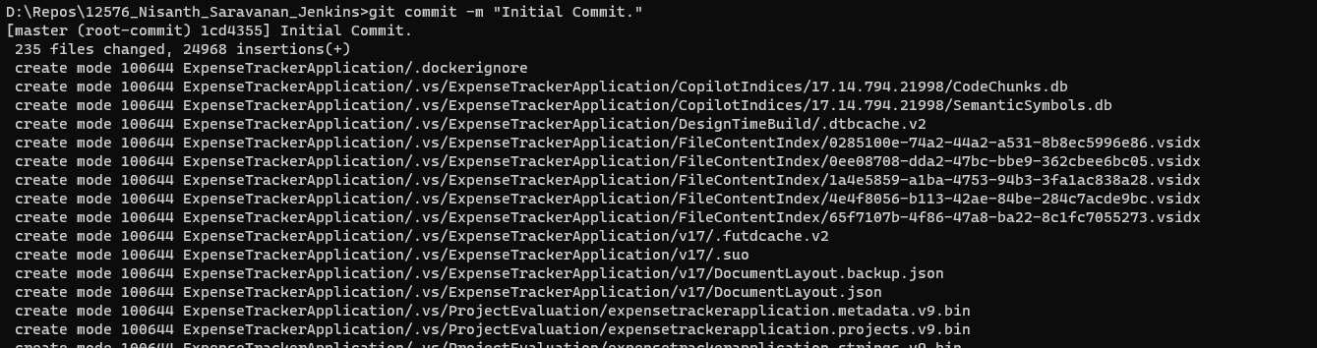

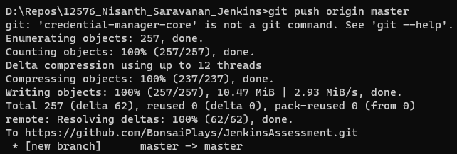

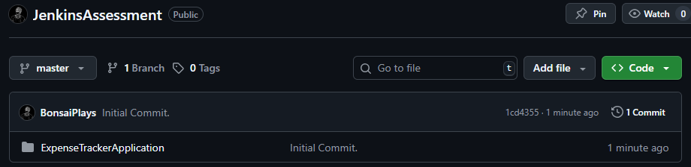

Current working files

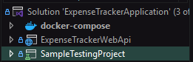

Along with a working react front-end.
Jenkins Work Flow

Create a new pipeline job in Jenkins

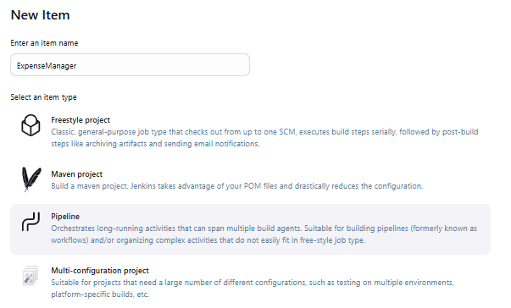
Proceed with scripting

Cherry-pick code from the repository

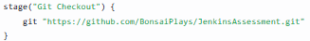

Build the Project

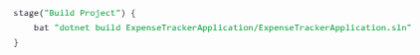

Test the project

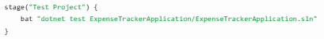

SonarQube

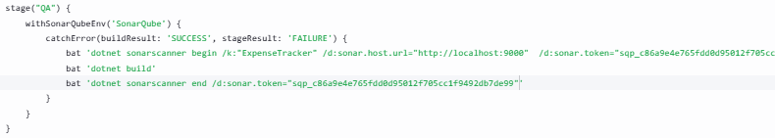

Allows the pipeline not to be aborted due to quality gates failure, for this assessment.

Docker
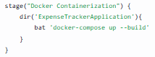

use: docker-compose up -d –build
in order to run in detached mode and reach a success status in the pipeline.
Complete Pipeline Script

node {
stage("Git Checkout") {
git "https://github.com/BonsaiPlays/JenkinsAssessment.git"
}
stage("Build Project") {
bat "dotnet build ExpenseTrackerApplication/ExpenseTrackerApplication.sln"
}
stage("Test Project") {
bat "dotnet test ExpenseTrackerApplication/ExpenseTrackerApplication.sln"
}
stage("QA") {
withSonarQubeEnv('SonarQube') {
catchError(buildResult: 'SUCCESS', stageResult: 'FAILURE') {
bat 'dotnet sonarscanner begin /k:"ExpenseTracker" /d:sonar.host.url="http://localhost:9000" /d:sonar.token="sqp_c86a9e4e765fdd0d95012f705cc1f9492db7de99"'
bat 'dotnet build'
bat 'dotnet sonarscanner end /d:sonar.token="sqp_c86a9e4e765fdd0d95012f705cc1f9492db7de99"'
}
}
}
stage("Docker Containerization") {
dir('ExpenseTrackerApplication'){
bat 'docker-compose up -d --build'
}
}
}
Stage View Output

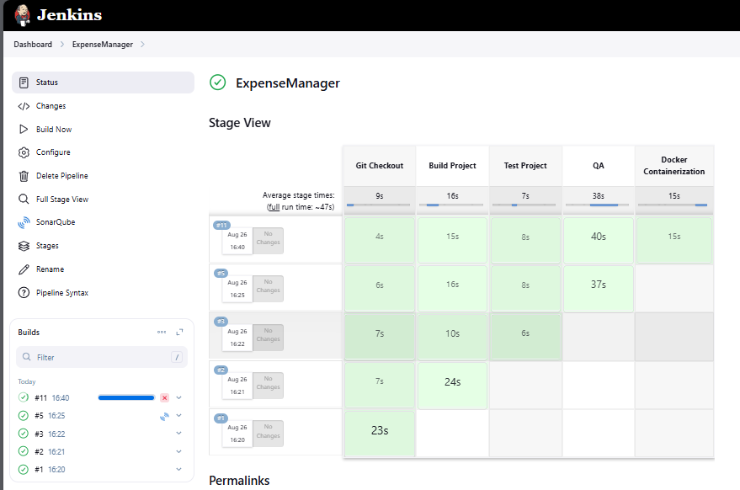

SonarQube Output

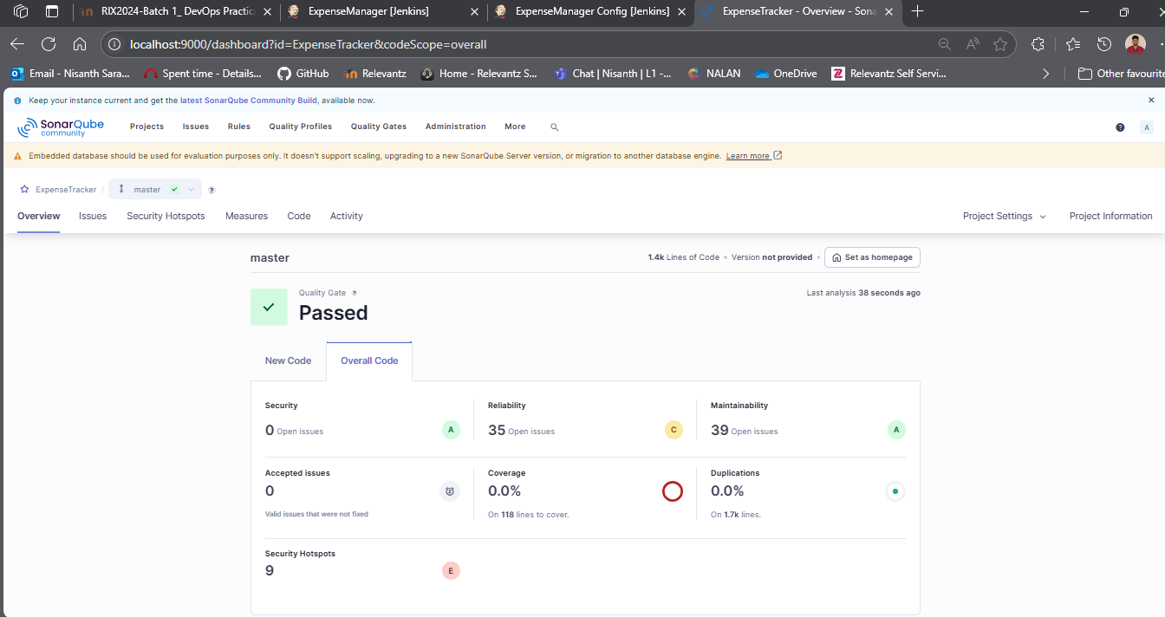

Docker Desktop Output – Initial

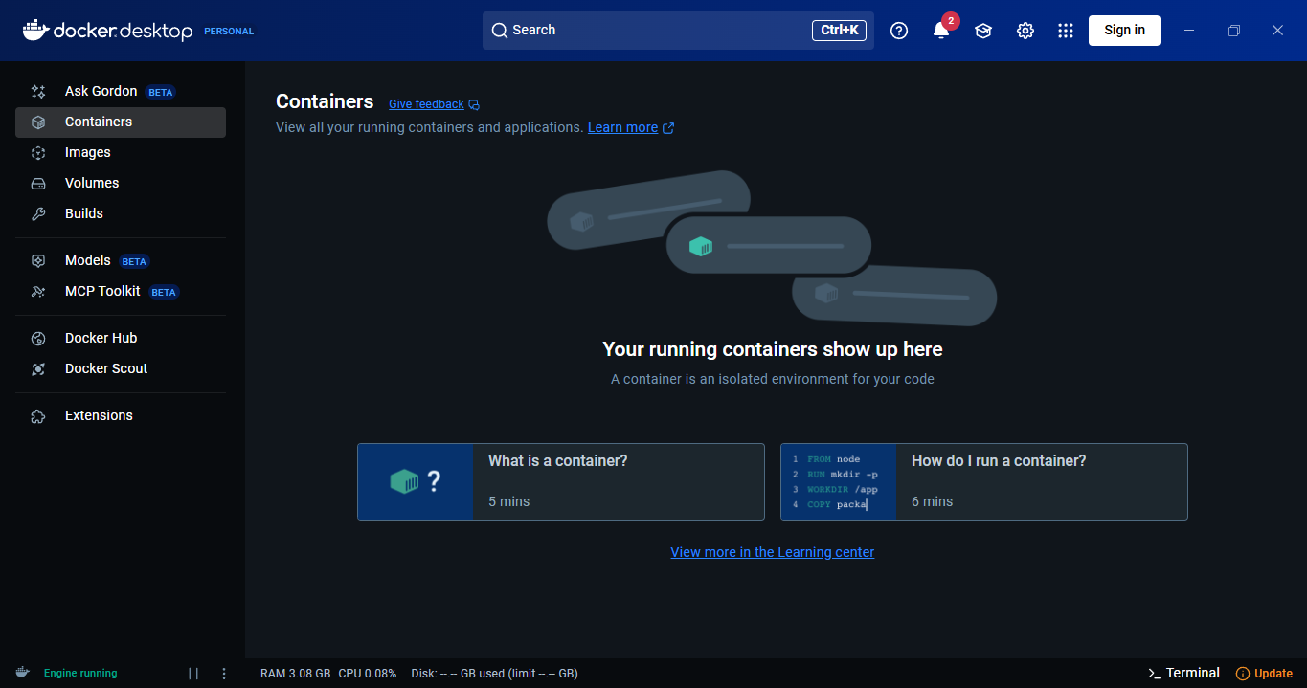

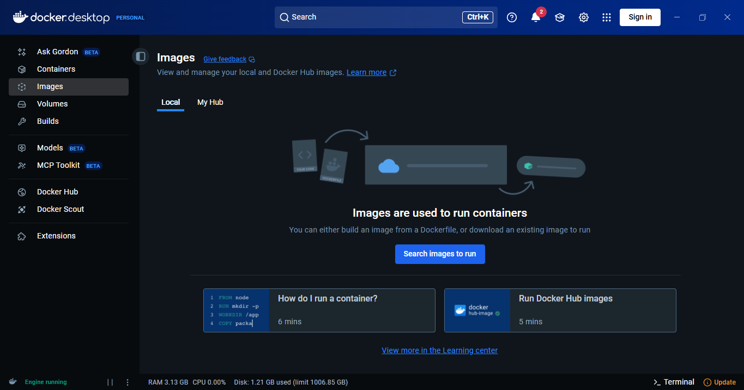
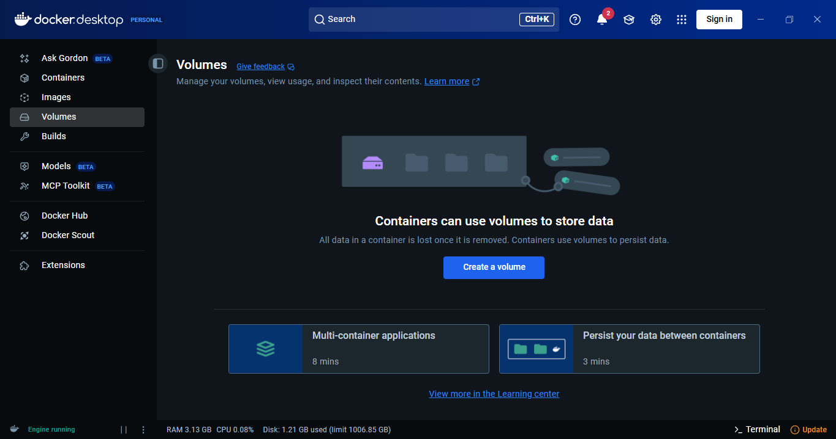

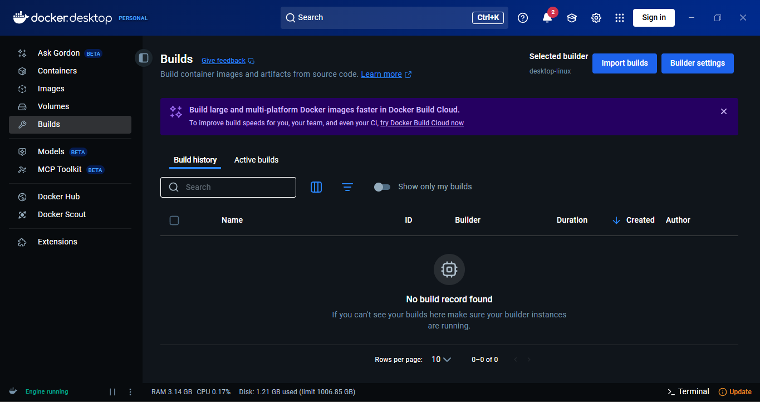
Docker Desktop After a Successful Jenkins Build Run

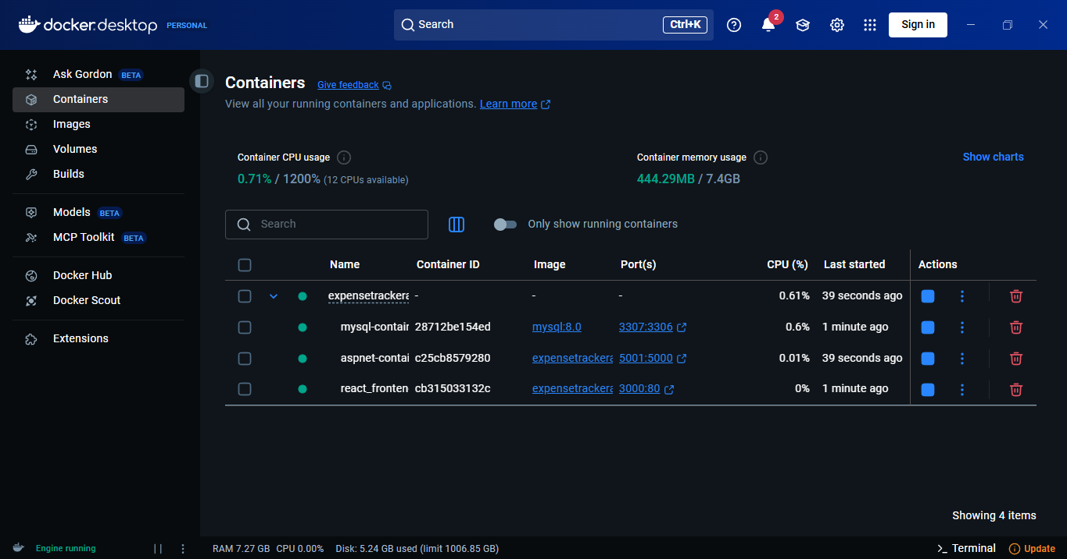

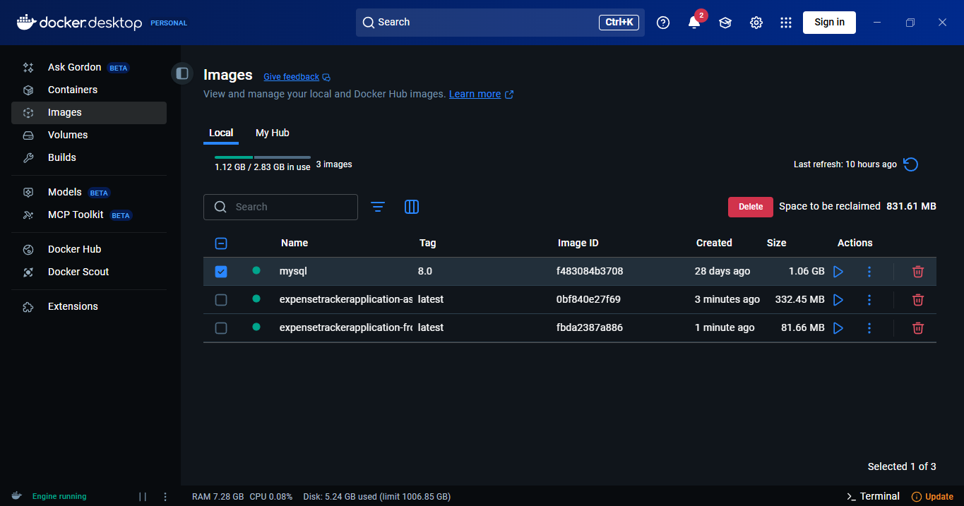

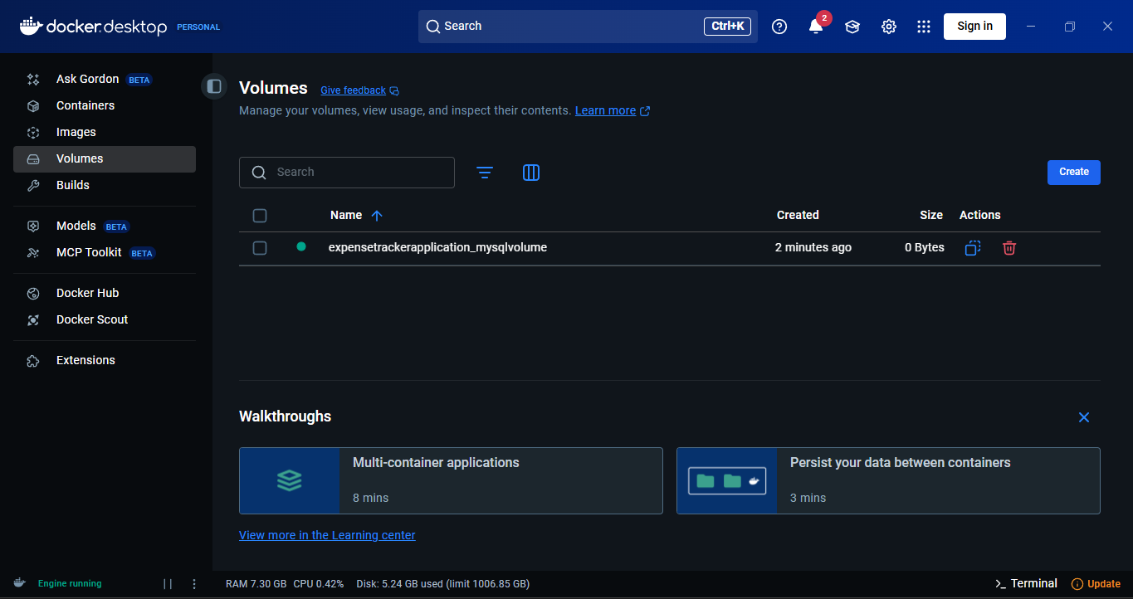

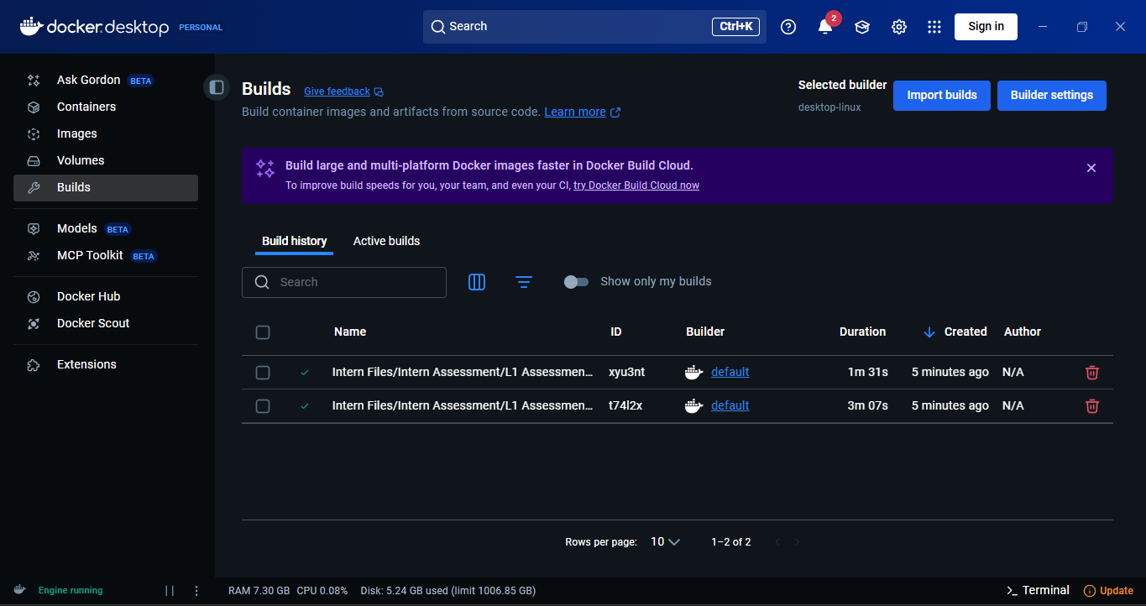
Containerized Outputs

Database

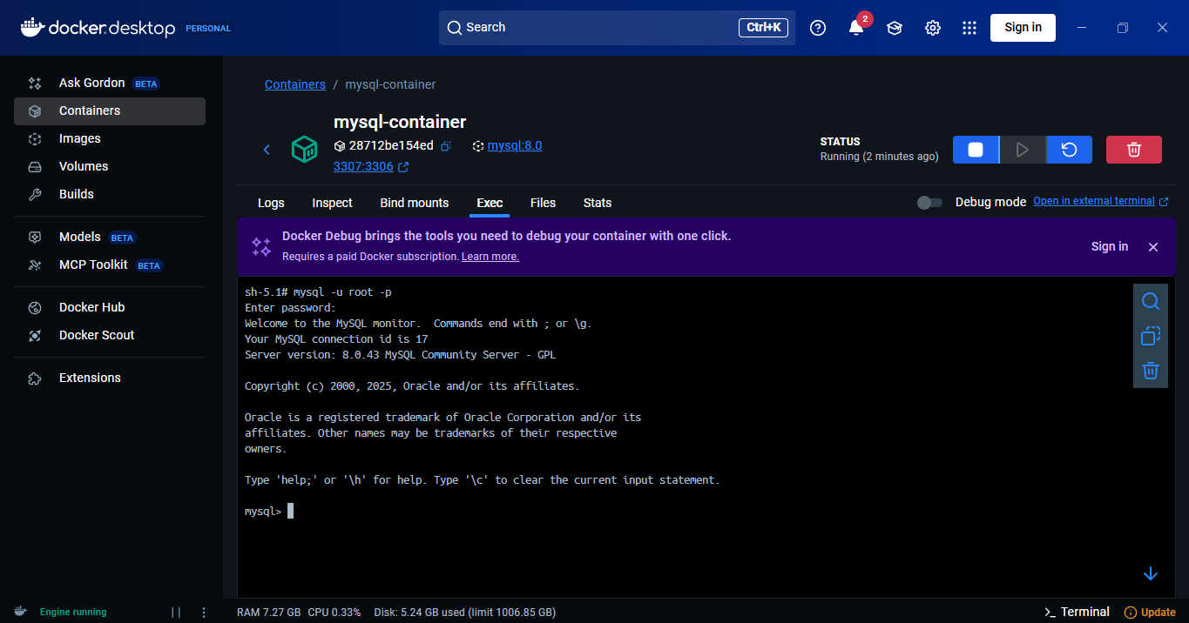

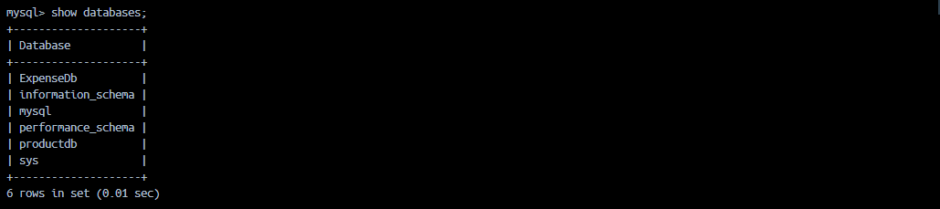

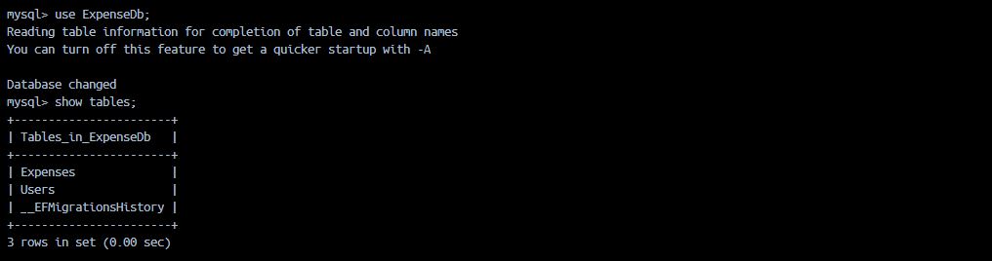
Web API

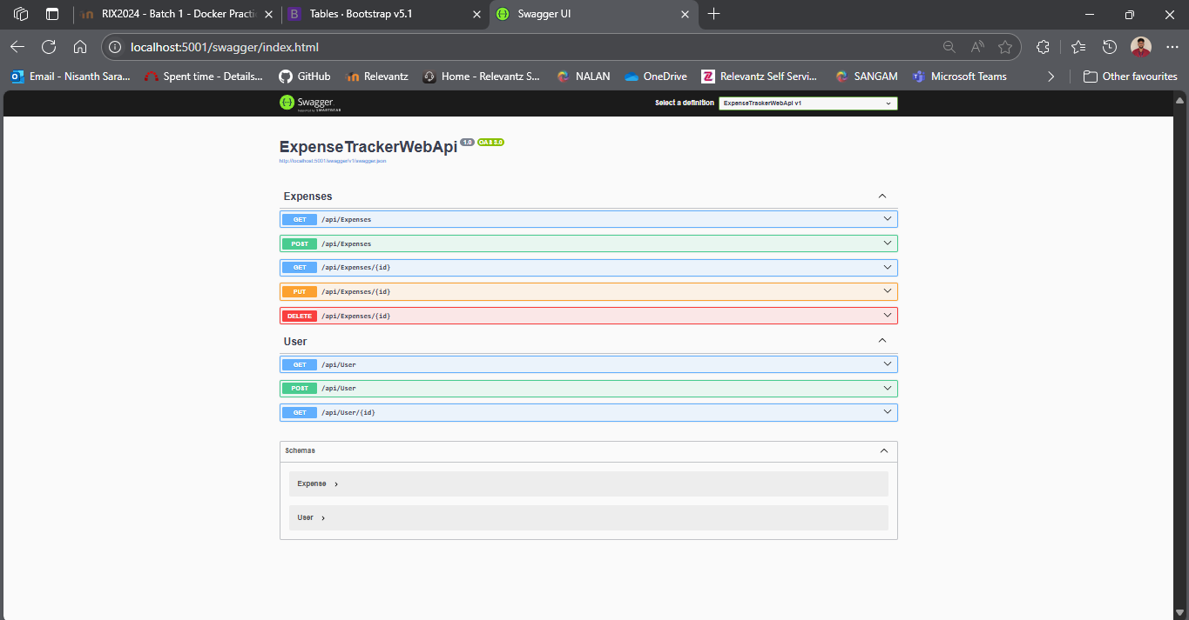

React Frontend

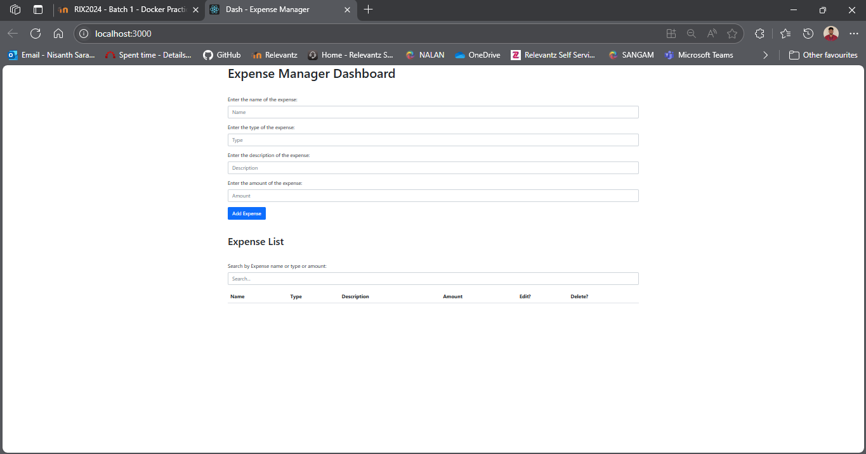
CRUD Operations

Create - Without Description

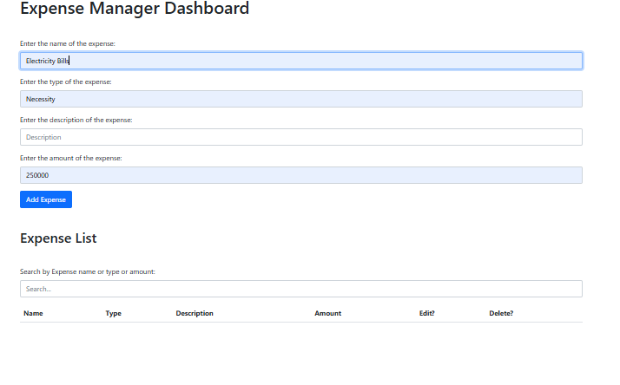

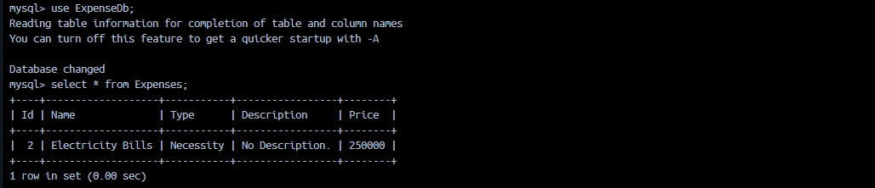

Create – With Description

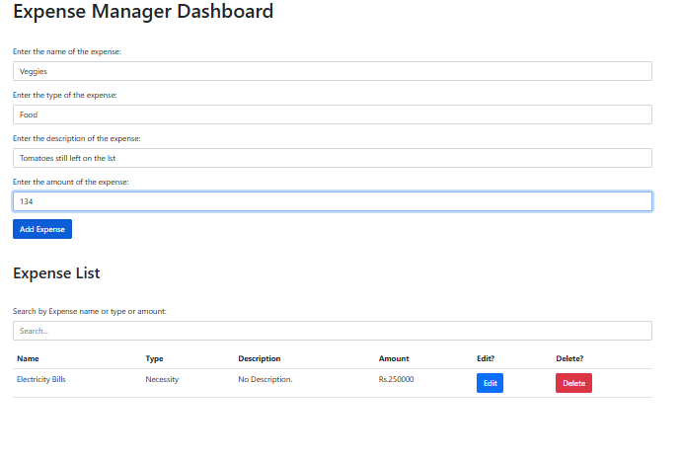

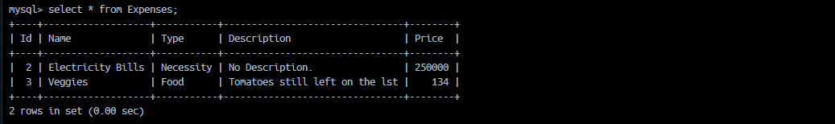
Edit

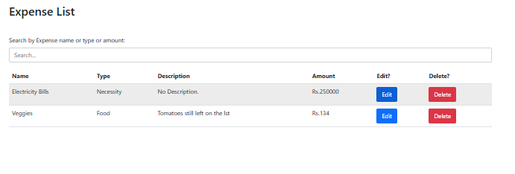

From
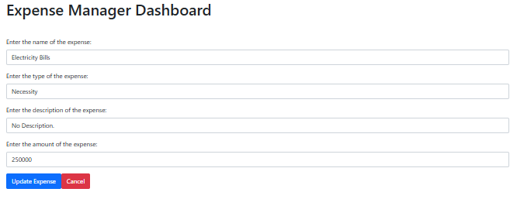

To
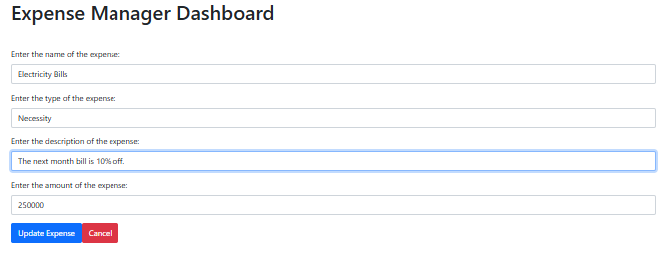
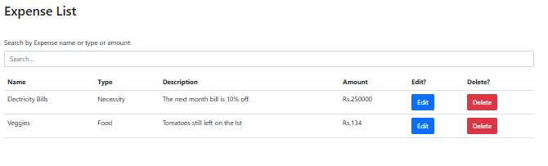

From

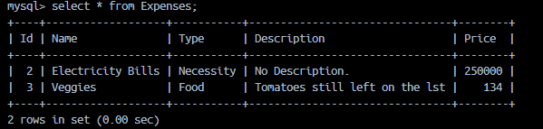

To

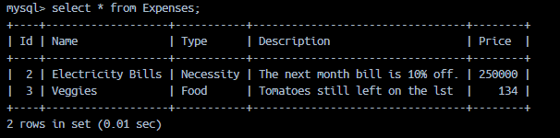
Delete

Before



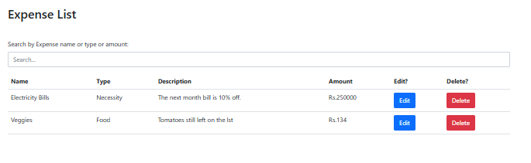

After

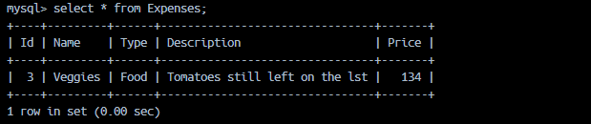

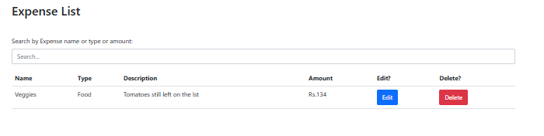
Searching

Sample Data

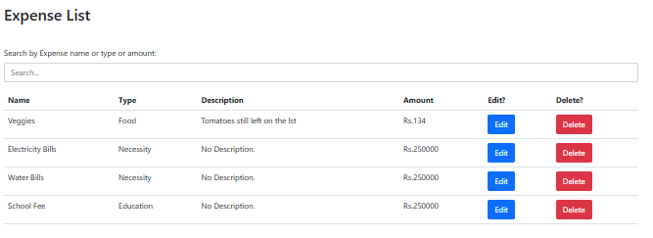

Searching By Name

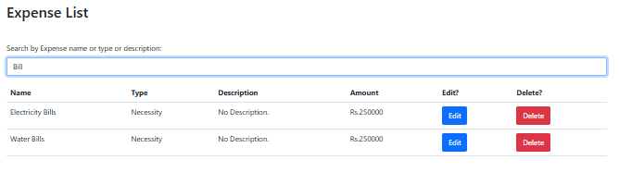

Searching By Type

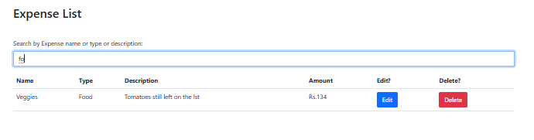

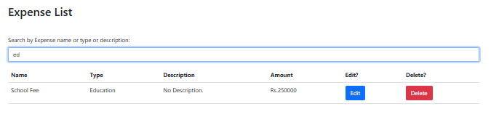

Searching By Description

